Supplementary Materials:

To provide a practical case study for the strategies proposed in this paper, this study includes the instructional design and assessment tools from the author's course, "Methods and Tools for Information System Development." These materials demonstrate how to guide students in the responsible use of AI and conduct in-depth assessments of their learning processes within a real-world educational setting. All materials have been anonymized to protect student privacy. All supplementary materials are stored in the following public repository:

List of Contents:

1. Course Slides and AI Usage Guidelines: Detailed course lecture slides, accompanied by a clear "AI Tool Usage Policy" for each lab session, which stipulates when and how students may use AI in their assignments.
PDF File: Methods and Tools for Information System Development Course Slides and AI Usage Guidelines .pdf

2. Rules and Requirements: Lab rules and final project requirements documents. These include lab rules designed to encourage creativity and assess higher-order thinking skills, as well as requirements for the "open-ended" final project.
(1) Lab Rules Documentation: lab-rules.ppt
(2) 2025 Methods and Tools for Information System Development Final Project Requirements.pdf

- Assignments and Grading Feedback: Includes lab documentation, final reports, and assessment feedback forms (which include AI interaction logs, reflections, and the final product):
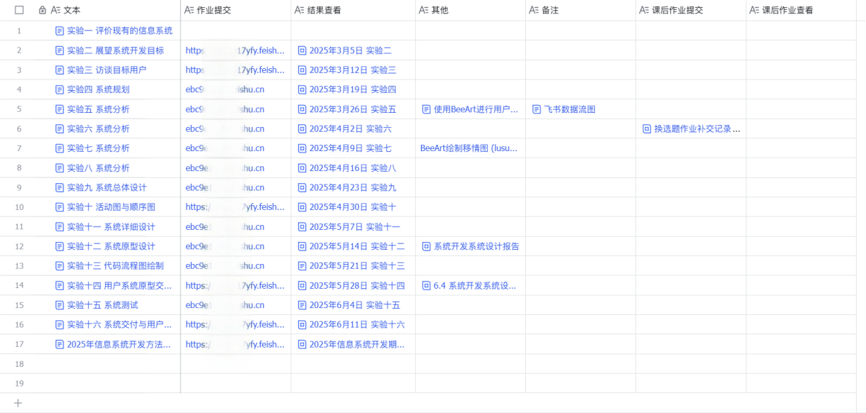
(1) Lab Documentation: There were 19 groups in the course. One group (Group 5) is selected as a representative example. The 16 lab documents from this group have been consolidated and anonymized: Group 5 Lab Documentation.pdf
(2) Final Report (Final Product): Group 5 Final Report.pdf
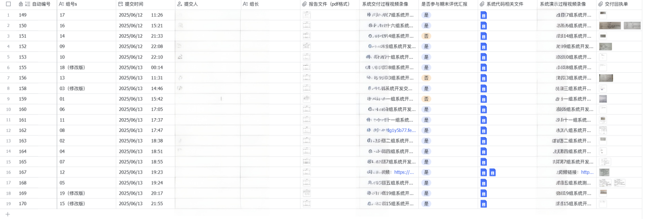
(3) Grading Feedback Sheet: InfoMgt Class Lab Grading Feedback Sheet.xlsx

